ODI-TFS-DbFit Integration

Contents
ODI-TFS-DbFit Integration 1
Contents 1
1 General Tools Installation 2
1.1 Install Microsoft Visual Studio 10 2
1.2 Install Microsoft TFS Power Tools 2010 2
1.3 Configure the PATH Environment Variable 2
1.4 Install Teradata Utilities 3
1.5 Create Standard File System Directories 3
2 ODI-TFS Integration 5
2.1 Initial Build of a Repository from Sources in TFS 5
2.2 Incremental Build of a Repository from Sources in TFS 17
2.3 The ODI-SVN Project 18
3 FitNesse and DbFit Configuration 29
3.1 FitNesse 29
3.2 DbFit 29
4 Reusing ODI Repositories 32
5 Appendices 33
5.1 Appendix A – Other Utilities 33

General Tools Installation

Install Microsoft Visual Studio 10
Install Visual Studio 10 from the path: -

\\stafs04\OnePlanDev2\MOI\Software\Microsoft Visual Studio\2010\TeamExplorer2010

Install Microsoft TFS Power Tools 2010
From the path \\stafs04\OnePlanDev2\MOI\Software\Microsoft Team Foundation Server open the file “tfpt.msi” and install the software into the recommended directory.

Configure the PATH Environment Variable
The following directories must be added to the system PATH environment variable: -
- C:\MOI\Configuration\Tools\Sysinternals
- C:\MOI\Configuration\Tools\UnixUtils\usr\local\wbin
- <path to the TFS command line utility “tf.exe”>

Note that path to “tf.exe” is often “C:\Program Files\Microsoft Visual Studio 10.0\Common7\IDE” when Visual Studio is installed in the default location.

Add these directories to the PATH environment variable either for the entire system or for your particular user. Do this from: Control Panel -> System -> Advanced -> Environment Variables.

Check that the TF command is now available to scripts by opening a new console window and executing the commands: -
- Start -> Run…Enter “cmd” and hit enter.
- Enter “tf /?” and hit enter.
- If you see a list of available sub commands then the PATH environment variable has been successfully set up for the TF command
- If you see “’tf ‘is not recognised as an internal or external command, operable program or batch file” then the PATH environment variable has NOT been correctly set up for the TF command. Review what you’ve previously done and correct where required.

Check that the PsExec command is now available to scripts by opening a new console window and executing the commands: -
- Start -> Run…Enter “cmd” and hit enter.
- Enter “psexec” and hit enter.
- If you see a dialogue box pop up (describing a license) then the PATH environment variable has been successfully set up for the PsExec command. Close the dialogue box / accept the licensing agreement.
- If you see text output from the “psexec” command then the PATH environment variable has been successfully set up for the PsExec command.
- If you see “’psexec‘is not recognised as an internal or external command, operable program or batch file” then the PATH environment variable has NOT been correctly set up for the PsExec command. Review what you’ve previously done and correct where required.

Check that the UnixUtils commands are now available to scripts by opening a new console window and executing the commands: -
- Start -> Run…Enter “cmd” and hit enter.
- Enter “gawk” and hit enter.
- If you see text output from the “gawk” command then the PATH environment variable has been successfully set up for the UnixUtils commands.
- If you see “’gawk‘is not recognised as an internal or external command, operable program or batch file” then the PATH environment variable has NOT been correctly set up for the UnixUtils commands. Review what you’ve previously done and correct where required.

Install Teradata Utilities
Install Teradata Fastload by running “TTU.exe” from the following path: -

- \\stafs04\oneplandev2\MOI\Software\Teradata\Teradata V13.10.02\TTU131002_LOADUNLD_V1\Windows

Select the ‘Typical’ installation type.

Test that Fastload has been correctly installed by running it from a new console window. I.e. Start->cmd.exe->Fastload.

You should see something similar to this: -

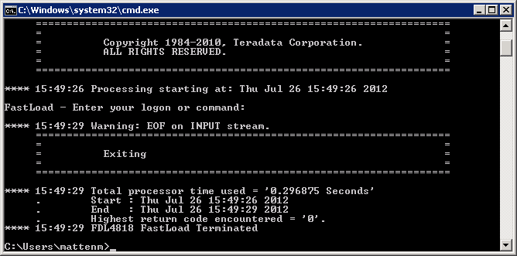

Create Standard File System Directories
Create the following file system directories: -
- C:\migdata
- C:\migdata\tdmoi

Note that other fixed subdirectories of “C:\migdata\tdmoi” may be required by some custom ODI Knowledge Modules (as the result of hard-coding) and these must be created as these are discovered.

ODI-TFS Integration

Initial Build of a Repository from Sources in TFS

Linking the Master and Work Repository Schemas
In our new configuration design we will host the master and work repositories in the same Oracle database schema but our legacy ODI environments have the master and work repositories hosted in separate schemas. The ODI-TFS integration code has been built to support both types of configuration and utilises Oracle database links to achieve this. So we need to create a database link between the master and work repository schemas: -

- Connect to the Oracle database as the owner of the master repository using TOAD, SQuirreL SQL, etc.
- Create the database link using the following command: -
  - CREATE DATABASE LINK odiworkrep_data CONNECT TO <work repository owner/user> IDENTIFIED BY <work repository owner/user password> USING ‘(DESCRIPTION=(ADDRESS_LIST=(ADDRESS=(PROTOCOL=TCP)(HOST=<work repository database host name>)(PORT=<work repository database TCP port>)))(CONNECT_DATA=(SERVER=DEDICATED)(SID=<work repository database SID>)))’;
  - Note that the values for the tokens, above, for development environments are typically: -
    - <work repository owner/user> - AOETL_DEVnn
    - <work repository owner/user password> - AOETL
    - <work repository database host name> - STAUDDBOP17
    - <work repository database TCP port> - 1526
    - <work repository database SID> - ODIDEV1

Getting the Tools and Source Code

SetupMyLocalWorkspace.bat
This is the place to start and should be run first.

This script performs the following actions: -

- Creates workspaces on your local machine – 1 for the Configuration/tools area, 1 for each of the major branches.
- Calls “GetWorkSpace.bat” which asks you to select which branch you’d like to download to your machine and then downloads the code (this is just a ‘get’ not a ‘check out’).

NOTE: we won’t be performing the ‘get’ part as we’ll be using a different script for this.

It must be run from a local directory. Use the following bootstrap procedure to get and run the initial set up scripts from TFS to a local directory: -

- Connect to the TFS server using Visual Studio.
- Create a new temporary TFS workspace. E.g. BUPA12345ZXCV_BootStrap.
- Map the TFS folder “$/MOIInternalReleases/Configuration/Scripts/Setup” to a new temporary local directory (e.g. C:\MOI\BootStrap).
- Switch to the new workspace in Visual Studio (from the Workspace dropdown).
- Get Lastest Version on the "$/MOIInternalReleases/Configuration/Scripts/Setup" folder in TFS.
- Start a command prompt window (Start->cmd.exe).
- Change working directory to the new temporary working directory using the command “cd /d C:\MOI\BootStrap.
- Run the batch file “SetupMyLocalWorkspace.bat”.

The batch file will then create a number of workspaces on the TFS server and corresponding local directories under the “C:\MOI” directory. It will also get the Configuration folder from the TFS server. The Configuration folder contains the standard MOI development tools. I.e. a development studio.

When asked whether you’d like to take no action or get (download) a branch, enter “0” to exit. You should see the following output.

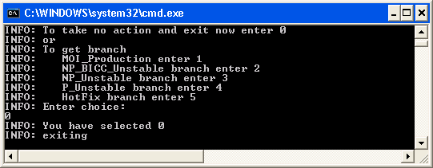
- Delete the temporary workspace using Visual Studio.
- Delete the temporary directory.

Make ODI Configuration Files Writable
Remove the read-only attribute from the following files: -

- C:\MOI\Configuration\Tools\odi\bin\snps_login_work.xml
- C:\MOI\Configuration\Tools\odi\bin\snps_login_security.xml
- C:\MOI\Configuration\Tools\odi\bin\userpref.xml
- C:\MOI\Configuration\Tools\odi\bin\ConfigTable.xml

Configure odiparams.bat
This must be configured to point to the ODI repository that is to be built from the source code in TFS.

The following section must be configured in the file: -

“C:\MOI\Configuration\Tools\odi\bin\odiparams.bat”: -

rem
rem Repository Connection Information
rem
rem ODI CONNECTION PARAMETERS START
set ODI_SECU_DRIVER=oracle.jdbc.driver.OracleDriver
set ODI_SECU_URL=jdbc:oracle:thin:@sta238:1526:odidev1
set ODI_SECU_USER=AOETL_DEV??
set ODI_SECU_ENCODED_PASS=c6yaHkzF2wi0XMOKv89Fs1UJ
set ODI_SECU_PASS=AOETL
set ODI_SECU_WORK_REP=WORKREP
set ODI_USER=SUPERVISOR
set ODI_ENCODED_PASS=a7ypx6q1nhHGmAgO4acSJbMxp
rem ODI CONNECTION PARAMETERS FINISH

Note that in most cases the only entry that needs to be updated is “ODI_SECU_USER” as all of the new development repositories are hosted in the same database and have the same password.

he value for this entry must be obtained from the MOI Config Team.
Note: do not delete the entries

rem ODI CONNECTION PARAMETERS START
and
rem ODI CONNECTION PARAMETERS FINISH

These entries have been added to the standard “odiparams.bat” and are required by the utility scripts.

Create a new empty Master and Work Repository

Master Repository
Navigate to the ODI bin directory at

C:\MOI\Configuration\Tools\odi\bin\odiparams.bat

Start the repository creation wizard “repcreate.bat”.

You will be asked to enter the connection details for the new ODI repository.

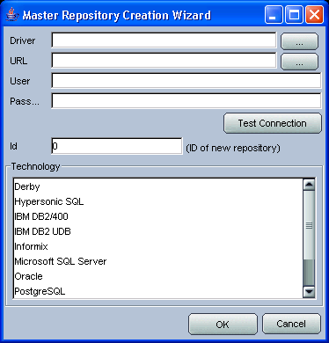

Complete the details to match those entered, previously, into the “odiparams.bat” script, selected the technology type for the repository, AND (most importantly) enter the unique ID for the repository allocated by the MOI Config Team. E.g.: -
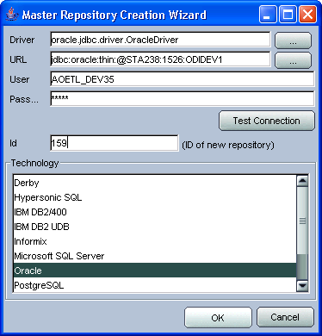

Note: the ID entered in this example (159). The repository ID is the most important value in any ODI code base. Ensure you use the value allocated by the MOI Config Team.

After entering these details a background console window will appear showing the progress of the creation of the repository structure and the import of the standard meta-data such as technology definitions.

Work Repository
After the Master Repository has been created we need to create the Work Repository. We will create a single Work Repository to be attached to the Master Repository and it will be hosted by the same Oracle database schema as the Master Repository.

We do not provide a unique name for the Work Repository but always use the name WORKREP as this, default name, is expected by utility scripts.

To create the new Work Repository first start the ODI Topology Manager (C:\MOI\Configuration\Tools\odi\bin\topology.bat) from the ODI bin directory and create a new Login so that we can connect to the new Master Repository from where we will create the new Work Repository.

Enter the Master Repository details into the form. The required/suggested values are given: -

Field | Value
Login Name | AOETL_DEV??@ODIDEV1
User | SUPERVISOR
Password | SUNOPSIS
User | AOETL_DEV??
Password | AOETL
Driver List | Oracle JDBC Driver
Driver Name | oracle.jdbc.driver.OracleDriver
Url | jdbc:oracle:thin:@sta238:1526:odidev1

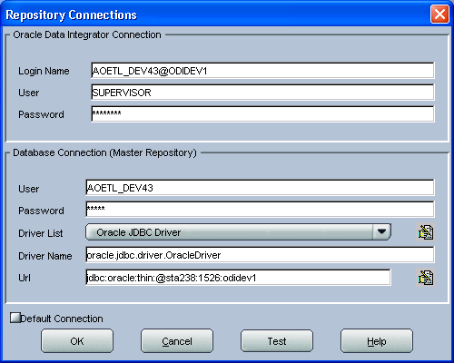

Click the ‘Test’ button to check the connection details then click OK to return to the login selection and log in to the new Master Repository.

Once connected, to the Repositories tab and right click on the Work Repositories node, then ‘Insert Work Repository’.

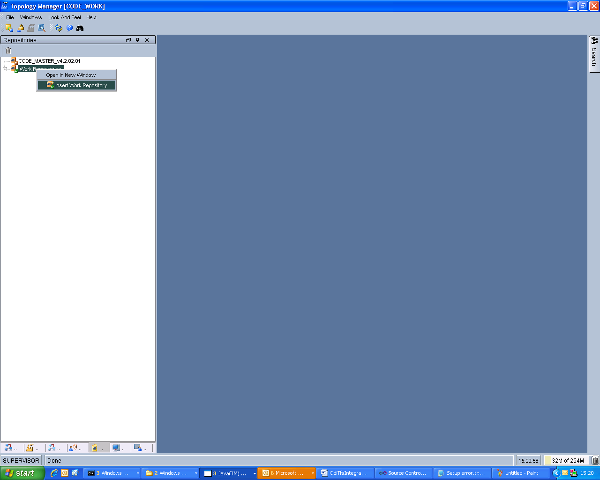

Enter the Work Repository connection details into the form. The required/suggested values are given: -

Field | Value
Name | WORKREP
Technology | Oracle
Instance (data server) | ODIDEV1
User | AOETL_DEV??
Password | AOETL
Driver Name | oracle.jdbc.driver.OracleDriver
JDBC Driver (JDBC tab) | Oracle JDBC Driver
JDBC Url (JDBC tab) | jdbc:oracle:thin:@sta238:1526:odidev1

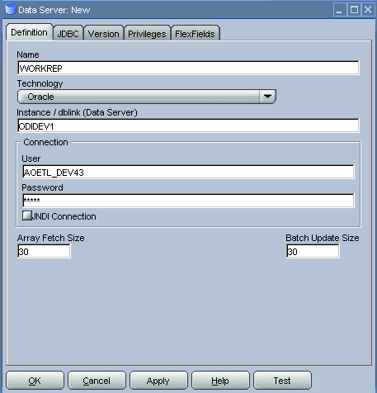

Enter the Work Repository details into the form. The required/suggested values are given: -

Field | Value
ID
Type | Development
Name | WORKREP

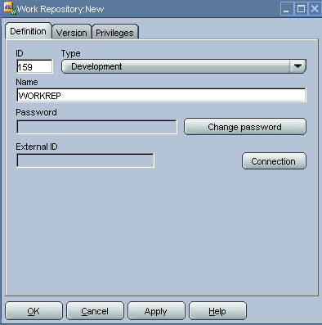

Note: do not click the connection button again; you have already defined the connection. It’s easy to go around in circles creating duplicate connections!

Click OK and ODI will start to create the new Work Repository. There is no progress shown but the operation should take only a few seconds.

Once the Work Repository has been created you’re ready to start importing source code.

Configure “TFSConfiguration.tfs”
The file determines the TFS server, project and branch that will be used to perform automated Get operations and imports of code into the ODI repository.

It is located in the directory “C:\MOI\Configuration”.

The file contains a column header row followed by a single data row. It has the following fields: -
- TFS server URL
- TFS project name
- TFS branch name

This file must be configured with the appropriate entries before any code can be retrieved from the TFS server and imported in an ODI repository using the automated solution scripts.

An example content of this file is: -

TFSServerURL,TFSProjectName,TFSBranchName
http://tfs:8080/tfs/bhwdevelopment,MOIInternalReleases,NP_Unstable

Download the Code and Generate the ODI Import Scripts
This process is performed using the PowerShell script “GetIncremental.ps1”.

Execute this as follows: -
- Start PowerShell using Start -> Run… -> powershell
- Change working directory to your branch root using “cd C:\MOI\<your branch name>”. E.g. “cd C:\MOI\NP_Unstable”.
- Execute the PowerShell script “C:\MOI\Configuration\Scripts\GetIncremental.ps1”.

GetIncremental.ps1 generates a set of batch files in a new directory under the “C:\MOI\Logs” directory. Each time GetIncremental.ps1 is run a new directory is created that is named with the date and time of the execution.

This directory contains the following files: -
- OdiSvnBuildNote_<yyyymmdd>_<hhmiss>.txt – build summary note.
- OdiSvnBuild_<yyyymmdd>_<hhmiss>.bat – main build script.
- Import_<yyyymmdd>_<hhmiss>.bat – ODI import script.
- OdiSvnGenScenPreImport_<yyyymmdd>_<hhmiss>.bat – set up for Scenario generation.
- OdiSvnGenScenPostImport_<yyyymmdd>_<hhmiss>.bat – generate Scenarios.
- odisvn_create_infrastructure_<yyyymmdd>_<hhmiss>.sql – creates custom ODI repository tables.
- odisvn_set_next_import_<yyyymmdd>_<hhmiss>.sql – maintains ChangeSet metadata in the custom ODI repository tables.

Run the Generated ODI Import Scripts
To start the import, of the ODI code, execute the generated main build batch file in the new directory under “C:\MOI”.

It is recommended to redirect the standard output and standard error channels messages to a log file when running this script.

To perform this run the batch file from a command prompt (cmd.exe) window with the following command line: -

cd C:\MOI\Logs\<yyyymmdd>_<hhmiss>.
OdiSvnBuild_<yyyymmdd>_<hhmiss>.bat >MyLogFile.txt 2>&1

The log file can be monitored by opening it periodically in a text editor or by installing UnixUtils (\\stafs04\OnePlanDev2\MOI\Software\Windows Command Line Tools) and running “tail –f MyLogFile.txt”.

The batch files generate additional log files in the same directory as they run.

Configure the ODI Export Mechanism
Configure the following ODI Topology items: -

- Data Server ODIMASTERREP_DATA to point to your master repository database. Also configure the physical schema under this data server with the name of your master repository schema. Update both the data and the work schema names with the same value.
- Data Server ODIWORKREP_DATA to point to your work repository database. Also configure the physical schema under this data server with the name of your work repository schema. Update both the data and the work schema names with the same value.
- The physical schema under the Data Server ODISVNWC_DATA to point to the root of your code branch directory. E.g. to “C:/MOI/NP_Unstable” (without the double quotation marks). Note that forward slashes are preferred in file names. Do this only for the Data schema. For the Work schema enter the path of a directory that is to be used, by the export mechanism, to create temporary work files. E..g. “C:/TEMP”, or “C:/OdiSvn_WorkArea”. NOTE that this directory must already exist before the export code can be run.
- Ensure that the logical schema ODIWORKREP_DATA is mapped to the physical schema that has been configured (above) under the “Global” context.
- Ensure that the logical schema ODIMASTERREP_DATA is mapped to the physical schema that has been configured (above) under the “Global” context.
- Ensure that the logical schema ODISVNWC_DATA is mapped to the physical schema that has been configured (above) under the “Global” context.

Manually Create the Repository Flush Metadata
Connect to the ODI repository, using TOAD or SQuirreL SQL, etc.

Perform the following manual updates to the custom repository tables that control the incremental export of ODI code: -

INSERT
INTO odisvn_work_flush_controls
(
odi_user_name
, flush_from_datetime
, flush_to_datetime
)
VALUES (
'SUPERVISOR'
, SYSDATE
, NULL
)
;

INSERT
INTO odisvn_master_flush_controls
(
odi_user_name
, flush_from_datetime
, flush_to_datetime
)
VALUES (
'SUPERVISOR'
, SYSDATE
, NULL
)
;

COMMIT
;

NOTE: this manual step will be automated by adding it to the build scripts in a future release.

Incremental Build of a Repository from Sources in TFS
Incremental builds are performed using the following procedure.

- Check out the entire ODI source code tree for your branch using Visual Studio (or the command line interface “tf.exe”).
- Export updated ODI code from the repository to the local workspace by running the Package OSUTL_FLUSH_REPOSITORY. This exports changes to both the master repository and work repository data.
  - NOTE that the Package/Procedure should be executed using the “Global” context only. This context should be the only context configured for the architecture/topology for the ODI-SVN project.
  - NOTE that the only Data Server and Physical Schema objects that will be exported are those that are mapped via the REFERENCE context and have the correct “REF_” prefix. No other Data Server or Physical Schema objects will be exported as these are configuration items rather than code items.
  - NOTE an alternative to running this procedure is to run the Procedure OSUTL_FLUSH_MASTER_REPOSITORY and the Procedure OSUTL_FLUSH_WORK_REPOSITORY separately.
- Undo any redundant ODI check outs using the TFS Power Tools command line tool “tfpt.exe” by running the following command line from your branch’s ODI source code root directory “tfpt uu”. Allow the tools to undo the redundant check outs by responding to the prompts.
- You could check your changes just exported into TFS at this point should you wish to.
- Run the PowerShell script again to get updates and import the updated ODI code: -
  - Start -> Run… -> cmd.exe -> “Powershell”
  - “C:\MOI\Configuration\Scripts\GetIncremental.ps1”.
  - If any conflicts exist the script will halt and conflicts must be resolved by the user and then this script re-run to get updates from the branch and import the new ODI code into the repository.
- Run the generated batch files to import the updated ODI code and generate the appropriate scenarios.
- You could also check your exported changes into TFS at this point too should you wish to.

The ODI-SVN Project

Overview
A set of ODI code objects (mainly procedures and variables) that are used to export ODI source objects to a file system so that they can be checked in to a source code version control system.

The ODI-SVN code ensures that exported code is created as the correct set of files, with the correct names, in the correct directories, and in some cases even modifies the XML that the ODI API creates in order to create a coherent set of source code.

When the project was started SVN (Subversion) was the intended source code control system. Hence the current name.

The project has the internal ID 9007.

Logical Schemas

ODIMASTERREP_DATA (Oracle Technology)
This logical schema represents the ODI Master Repository schema (i.e. the schema containing the ODI Master Repository data).

It allows the ODI-SVN code to execute SQL queries against the ODI Master Repository data.

ODIWORKREP_DATA (Oracle Technology)
This logical schema represents the ODI Work Repository schema (i.e. the schema containing the ODI Work Repository data).

It allows the ODI-SVN code to execute SQL queries against the ODI Work Repository data.

ODISVNWC_DATA (File Technology)
This logical schema represents the file system area that is used to interact with the version control system. E.g. an SVN working copy, a TFS local folder mapped from a repository folder, etc.

It allows the ODI-SVN code to provide code to the version control system for the purposes of conflict detection and checking in to the version control system.

Reference Data Servers

REF_ODIMASTERREP_DATA (Oracle Technology)
This data server is part of the standard REFERENCE physical architecture for the ODIMASTERREP_DATA logical schema.

REF_ODIWORKREP_DATA (Oracle Technology)
This data server is part of the standard REFERENCE physical architecture for the ODIWORKREP_DATA logical schema.

ODISVNWC_DATA (File Technology)
This data server is part of the standard REFERENCE physical architecture for the ODISVNWC_DATA logical schema.

Reference Physical Schemas

REF_ODIMASTERREP_DATA.REF_ODIMASTERREP_DATA (Oracle Technology)
This physical schema is part of the standard REFERENCE physical architecture for the ODIMASTERREP_DATA logical schema.

REF_ODIWORKREP_DATA.REF_ODIWORKREP_DATA (Oracle Technology)
This physical schema is part of the standard REFERENCE physical architecture for the ODIWORKREP_DATA logical schema.

REF_ODISVNWC_DATA.REF_ODISVNWC_DATA (File Technology)
This physical schema is part of the standard REFERENCE physical architecture for the ODISVNWC_DATA logical schema.

Predefined Data Servers
The following Topology items are predefined, for convenience of the user, and are required to be configured by the user to create the working system.

ODIMASTERREP_DATA (Oracle Technology)
This data server must be configured by the user to point to their master repository database.

ODIWORKREP_DATA (Oracle Technology)
This data server must be configured by the user to point to their work repository database.

ODISVNWC_DATA (File Technology)
This data server requires no configuration.

Predefined Physical Schemas
The following Topology items are predefined, for convenience of the user, and are required to be configured by the user to create the working system.

ODIMASTERREP_DATA.$DBUSER (Oracle Technology)
This physical schema must be configured by the user to point to their master repository database schema. Both the data and work schemas should be set to the master repository database schema name.

ODIWORKREP_DATA.$DBUSER (Oracle Technology)
This physical schema must be configured by the user to point to their work repository database schema. Both the data and work schemas should be set to the master repository database schema name.

ODISVNWC_DATA.C:/MOI/Development/ODI/Source (File Technology)
This physical schema must be configured by the user to point to their branch’s working copy (workspace) root directory. The data schema must be set to the actual branch root directory and the work schema must be set to a directory where the ODI export mechanism can create temporary/working files.

Logical-to-Physical Architecture Mappings
The “Global” context is used to execute the ODI export operations.

The following mappings must be in place to use the solution: -

Context | Logical Schema | Physical Schema
Global | ODIWORKREP_DATA | ODIWORKREP_DATA.<work repository schema>
Global | ODIMASTERREP_DATA | ODIWORKREP_DATA.<master repository schema>
Global | ODISVNWC_DATA | ODISVNWC_DATA.<branch root directory>

The user must ensure that these are configured correctly before using the export solution.

Main Procedures

OSUTL_FLUSH_MASTER_REPOSITORY
This procedure will export any new and modified master repository code items since the last time that this procedure was run successfully.

If configured to do so, the procedure can check out the exported files from a Version Control System as the files are exported.

The metadata table ODISVN_MASTER_FLUSH_CONTROLS tracks the starting date/time of the previous execution and this date/time is used for the next execution.

Note that the current implementation does not distinguish between completed and any work-in-progress code.

OSUTL_FLUSH_WORK_REPOSITORY
This procedure will export any new and modified work repository code items since the last time that this procedure was run successfully.

If configured to do so, the procedure can check out the exported files from a Version Control System as the files are exported.

The metadata table ODISVN_WORK_FLUSH_CONTROLS tracks the starting date/time of the previous execution and this date/time is used for the next execution.

Note that the current implementation does not distinguish between completed and any work-in-progress code.

OSUTL_FLUSH_WORK_REPOSITORY_DELETIONS
This procedure will synchronise the local file system copy of the code with deleted ODI objects. To perform this the procedure compares the repository objects against the file system files and deletes from the file system the files for any ODI objects that are not in the repository.

If configured to do so, the procedure can stage (i.e. stage a change to be committed later) the deletion of the files from a Version Control System as the files are deleted.

OSUTL_EXPORT_MASTER_REPOSITORY
This procedure will export all master repository code items.

Note that the current implementation does not distinguish between completed and any work-in-progress code.

OSUTL_EXPORT_WORK_REPOSITORY
This procedure will export all work repository code items.

Note that the current implementation does not distinguish between completed and any work-in-progress code.

Low Level Procedures

Code Object Exporters
A procedure exists for each type of code object that is exported to the file system. Scenarios of these procedures are called from the main procedures to do the actual exports.

These are named “OSUTL_EXPORT_<code object type>”. E.g. “OSUTL_EXPORT_DATA_STORE”. They are located in the folders “MASTER_REPOSITORY_OBJECTS” and “WORK_REPOSITORY_OBJECTS”.

The Scenarios may also be executed directly and allow the user to enter the internal ID of a specific object instance. This allows the user fine grained control if/when required. E.g. there is a need to export (for some reason, perhaps the need to fast-track the promotion of a subset of objects from a development) an object that has not been recently modified and would not be selected for export by the ‘flush’ procedure.

Note that executing the Scenarios directly does not maintain the ‘flush’ metadata and executing the regular ‘flush’ procedures could cause the object to be re-exported.

Common Helpers
A number of utility procedures exist that are used by both the work and master repository export procedures. These perform common actions such as cleansing the export files to remove the first/last user name and first/last timestamp so that these do not show up as development change conflicts that must be resolved, etc.

These are named “OSUTL_<function>”. E.g. “OSUTL_EXPORT_OBJECT”. They are located in the folder “COMMON”.

Packages

Variables

Inter-session Communication

Project Configuration

VCSRequiresCheckOut

VCSBasicCommand

VCSCheckOutCommand

VCSDeleteCommand

Notable Export Mechanism Behaviour
- Scenarios are generally not exported to the file system. They are deleted before the source object is exported then re-imported afterwards. The exception to this is the ODI-SVN project where the scenarios all have version 999 and are included in the export.
- Only REFERENCE physical architecture is exported by the export mechanism. This includes Logical to Physical Schema mappings and the export code removes non REFERENCE context mappings from the exported Logical Schema files.
- Incremental exports are controlled by the custom repository tables ODISVN_MASTER_FLUSH_CONTROLS (located in the master repository) and ODISVN_WORK_FLUSH_CONTROLS (located in the work repository). These tables are created any maintained automatically by the export mechanism.
- Export files are named using the internal ID of the object plus the ODI class name as the suffix. This mirrors how objects are identified in ODI and these are: -
- SnpContext - contexts.
- SnpConnect - data servers (REFERENCE architecture only).
- SnpPschema - physical schemas (REFERENCE architecture only).
- SnpLschema - logical architecture.
- SnpProject - projects
- SnpFolder - folders
- SnpPop - interfaces
- SnpTrt - procedures and Knowledge Modules
- SnpVar - variables (project and global)
- SnpUfunc - user functions (project and global)
- SnpSequnce - sequences (project and global)
- SnpGrpState - marker groups
- SnpModel - models
- SnpSubModel - sub models (each model contains a hidden sub model)
- SnpTables - data stores
- SnpJoin - references (relationships)

Beware of the Dog!
These are the major points to note to avoid major issues!

- The import process is generally safe as the PowerShell scripts and the generated batch files check the integrity of the ODI repository against the local workspace before any import operations can be run.
  - These scripts track ChangeSet metadata in a custom repository table (ODISVN_CONTROLS) and a pair of the local files (TFSGetChangeSetsLocalControls.tfs – the latest ChangeSet downloaded from TFS, and TFSGetChangeSetsODIRepoControls.tfs – the latest ChangeSet that we’ve generated an import script for and this is checked against the ChangeSet number in the custom repository table).
  - They also track the branch that has been used to import code from. It is generally NOT SAFE to switch the source branch use to import into a repository. The repository must be cleared down first.
- Don’t just trash an ODI repository and create a new one with the same internal ID is there is ANY chance that objects were created in the repository and released to other repositories or checked into TFS.
  - To do this the tables SNP_ID (work repository) and SNP_ENT_ID (master repository) must be backed up and restored after recreating the repository. This will ensure that new objects created do not use ID previously allocated to other objects. The integrity can be check at any time using the SQL script “OdiSvnValidateRepositoryIntegrity.sql” found in the “Configuration\Scripts” folder in TFS.

FitNesse and DbFit Configuration
The standard MOI directory structure supports multiple FitNesse installations to allow for a single server machine to run FitNesse instances for multiple common automated build environments.

The standard directory for FitNesse installations is: -

- C:\MOI\Configuration\Tools\FitNesse\dbfit-complete-20080822_<name>

Where: -
- <name> is simply an identifier to provide a unique directory name. E.g. DEV1, NP_STABLE.

For standard developer machines only a single installation of FitNesse (and ODI) is required and the TFS repository already contains a predefined directory (appended with DEV1) that can be configured for use.

FitNesse
The following entries must be configured to use a FitNesse installation.

MoiFitNesseOdiEnv.bat
This file is located within each “dbfit-complete-20080822_<name>” directory.

Configure the following entries: -
- set MOI_FITNESSE_PORT=<local TCP port>
- set MOI_DEVELOPMENT_ROOT=<path to FitNesseRoot>

E.g. to configure FitNesse to listen for HTTP requests on port 8085 (the default in the MOI configuration) and to use test pages from the code branch “NP_Stable”, set the entries to: -
- set MOI_FITNESSE_PORT=8085
- set MOI_DEVELOPMENT_ROOT=C:\MOI\NP_Stable

NB: the path to the FitNesseRoot directory must be one of the standard local MOI code branch workspace root directories.

DbFit

Data Source Connections
These files are located within each “dbfit-complete-20080822_<name>” directory.
- DATASERVER_<System>_JDBC.properties
- DATASERVER_<System>.NET.properties

The contents of these files must be configured with the connection details for the systems that will be used in tests.

Logical to Physical Schema Mappings
The file “LOGICAL_PHYSICAL_SCHEMA_MAPPINGS.properties” maps the logical schema name, used in test pages, to the physical schema name to be used when test pages are executed. The logical schema names used in test pages in general follow the logical schema names used for the corresponding ODI logical schema name. The exceptions are where non-standard logical schema names have been used and have not yet been corrected.

E.g. the DbFit logical schema name for SWIFT is SWIFT_DATA (for the Oracle database) and MOI_A_UKM_SWFT_DATA (for the Teradata database). In ODI these are still named MOVE and TD_DEV_DATA respectively.

This file is located within each “dbfit-complete-20080822_<name>” directory.

Note that the assigned mappings can be seen in FitNesse from the Wiki page: -
- MoiDemonstration.DisplayLogicalPhysicalSchemaMappings

Integration with ODI

ODI Home Directory
The batch file “MoiFitNesseOdiEnv.bat” is located within each “dbfit-complete-20080822_<name>” directory.

Configure the following entries: -
- set ODI_HOME=<path to ODI home directory>

E.g. to configure the standard ODI Scenario execution batch file (MoiExecOdiScen.bat) to use the ODI installation at “C:\MOI\Configuration\Tools\odi” (an ODI home directory, containing the other ODI directories such as bin, drivers, etc), set the entry to: -
- set ODI_HOME= C:\MOI\Configuration\Tools\odi

ODI Execution Context
The batch file “MoiFitNesseOdiEnv.bat” is located within each “dbfit-complete-20080822_<name>” directory.

Configure the following entries: -
- set ODI_CONTEXT=<ODI execution context>

E.g. to configure the execution context for ODI Scenarios to GLOBAL, set the entry to: -
- set ODI_CONTEXT=GLOBAL

NB: the GLOBAL context is the default context that is predefined in this batch file and it is highly recommened that this context be used.

The file “LOGICAL_PHYSICAL_SCHEMA_MAPPINGS.properties” is also be used to load other environment variables and make them available to the FitNesse environment.

One of these is “ODI_CONTEXT”. This variable is loaded only for backward compatibility with older versions of the DbFit/ODI interface batch file (MoiExecOdiScen.bat) which used to require a context passed to it as part of the command.

If loaded and passed to the DbFit/ODI interface batch file then its value will be used to execute the Scenario. If no context is passed to the interface batch file then

References to this variable should no longer be included in ODI based test pages.

Reusing ODI Repositories
An ODI repository, built using the scripts generated by the GetIncremental PowerShell script, can be reused / rebuilt at a later time, using GetIncremental genereated scripts again. The source branch, from the TFS source control system, does not have to be the same as the original build.

The rebuild can only be performed safely with careful management of the following repository table contents between the builds: -

- SNP_ENT_ID
- SNP_ID

These tables are used by ODI to allocate internal IDs of new object created via the GUI (e.g. projects, interfaces, data servers, etc) or by batch processes (e.g. sessions, session steps). The following scripts are used to manage the contents of these tables to allow a repository to be destroyed and recreated and safely repopulated

OdiSvnTearDownRepository.sql

This script backs up the tables above by copying them to the following tables names in the same schema as the repository and then drops all other tables in the schema: -
- ODISVN_TEARDWN_BKUP_SNP_ENT_ID.
- ODISVN_TEARDWN_BKUP_SNP_ID.

OdiSvnTearDownMasterRepositoryIDs.sql

This script restores the master repository ID allocation table data.
This must be run after the empty master repository has been recreated using the ODI repository creation wizard (using the original master repository ID) and before the first master repository item is created (including defining any work repositories).

OdiSvnTearDownWorkRepositoryIDs.sql

This script restores the work repository ID allocation table data.
This must be run after the empty work repository has been recreated using the ODI repository creation wizard (using the original work repository ID) and before the first work repository item is created.

Appendices

Appendix A – Other Utilities

OdiImportFromPathOrFile.bat
This batch file is used to import any set of files located in a single directory tree. The files can be dispersed in any subdirectory. The script will ensure that the files will be imported in the correct order, based upon the file type / name extension. E.g. all *.SnpPop files are imported before all *.SnpPackage files.

This script should not be used for day to day build

This batch file has the following parameters: -

- Source Code Directory Root.
- OBI bin directory.
- Optional: source code object list override file.

We will generally use only the first two parameters and supply arguments for these.

E.g. to import the source code from a working copy of the main Non-Change-Programme branch the following would be executed: -

C:\MOI\Configuration\Scripts\OdiImportFromPathOrFile.bat C:\MOI\IDW\ODI\Source C:\MOI\Configuration\Tools\odi\bin

For large / long running imports, such as the initial population of an empty repository, it’s usually best to redirect the stdout and stderr from the commands to a log file using Unix-style redirection: -

C:\MOI\Configuration\Scripts\OdiImportFromPathOrFile.bat C:\MOI\IDW\ODI\Source C:\MOI\Configuration\Tools\odi\bin >C:\MyODIImport.log 2>&1

The log file can then be monitored or checked periodically for failures.

